COMP1562 – Operating System

Laboratory 6

Scheduling

Group ID: 21

Group Task: Task 5

Usman Basharat

Mohamed Aden

Yunus Hassan

Derek U. Mafohla

Table of Contents

Exercise One 3

First Come First Serve 3

Round Robin 4

Shortest Job First 6

Task 5.1 8

First Comes First Served. 8

Task 5.2 9

Shortest Job 9

Reflection 11

## Exercise One

## First Come First Serve

Process 1 30ms

Process 2 30ms

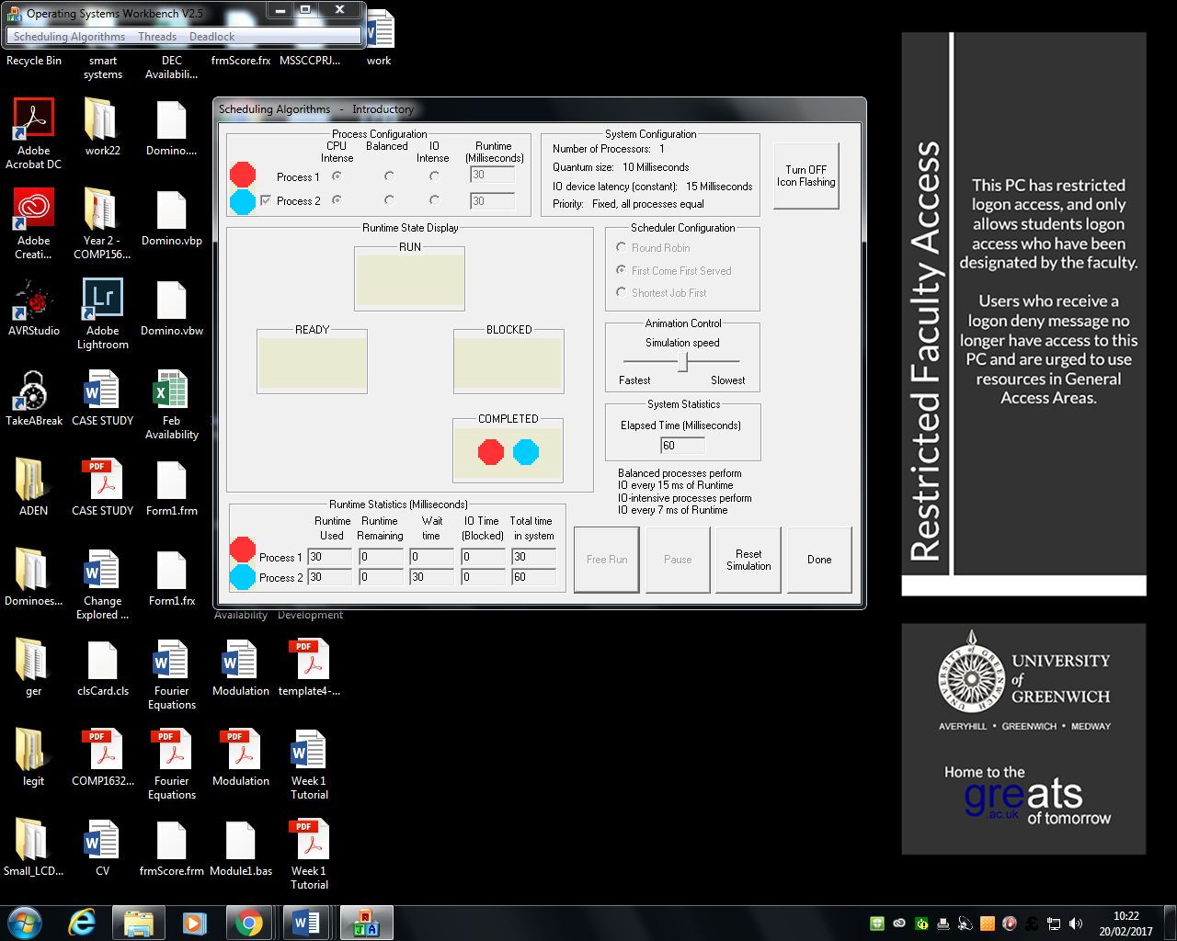

Process 1 300ms

Process 2 30ms

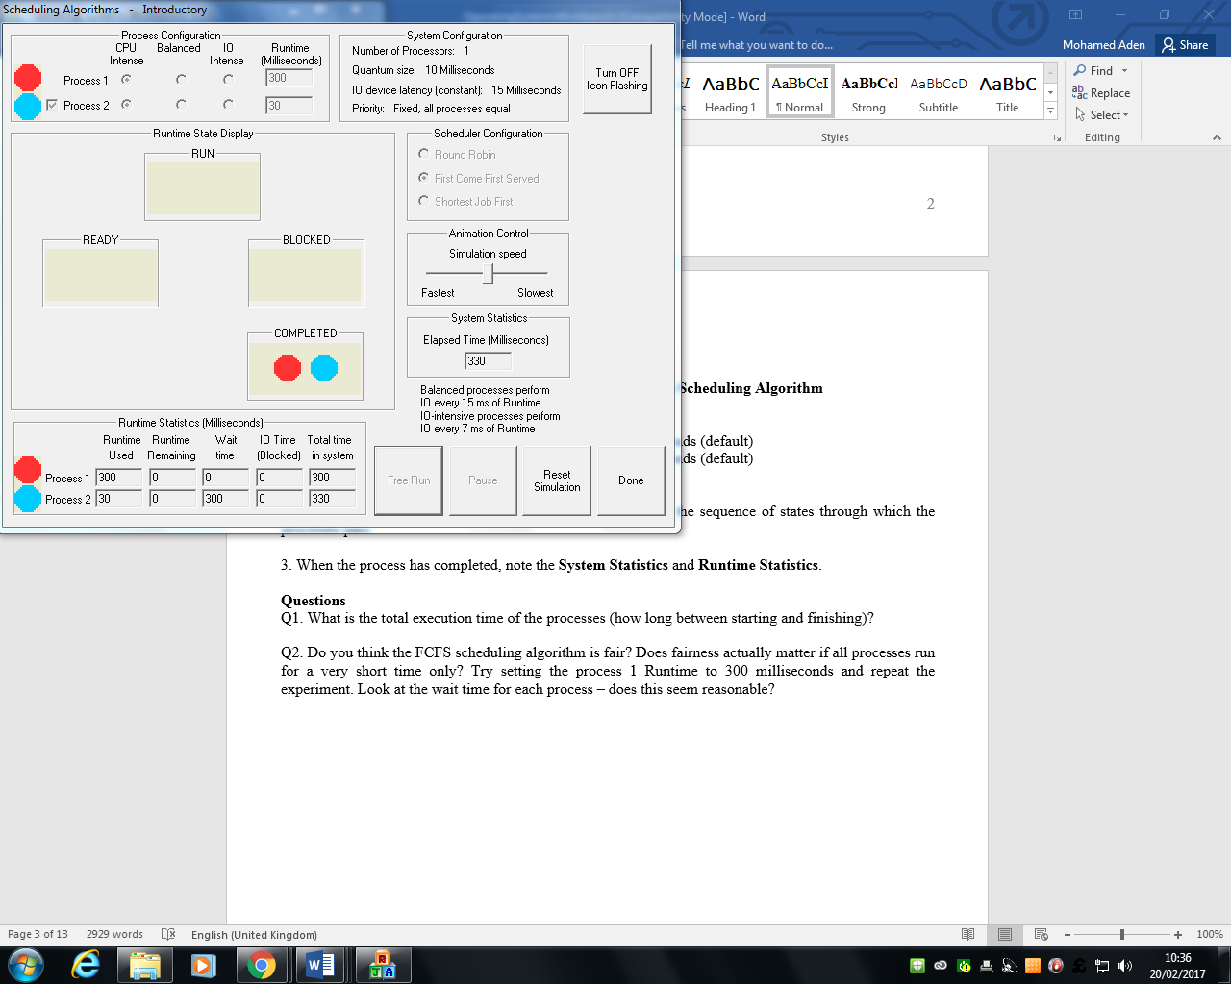

Process 1 30ms

Process 2 300ms

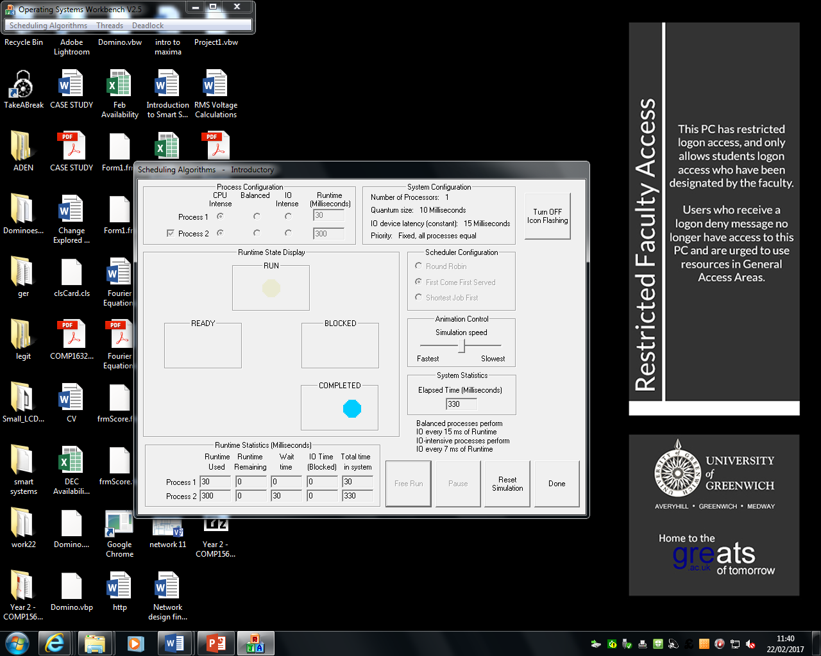

## Round Robin

Process 1 30ms

Process 2 30ms

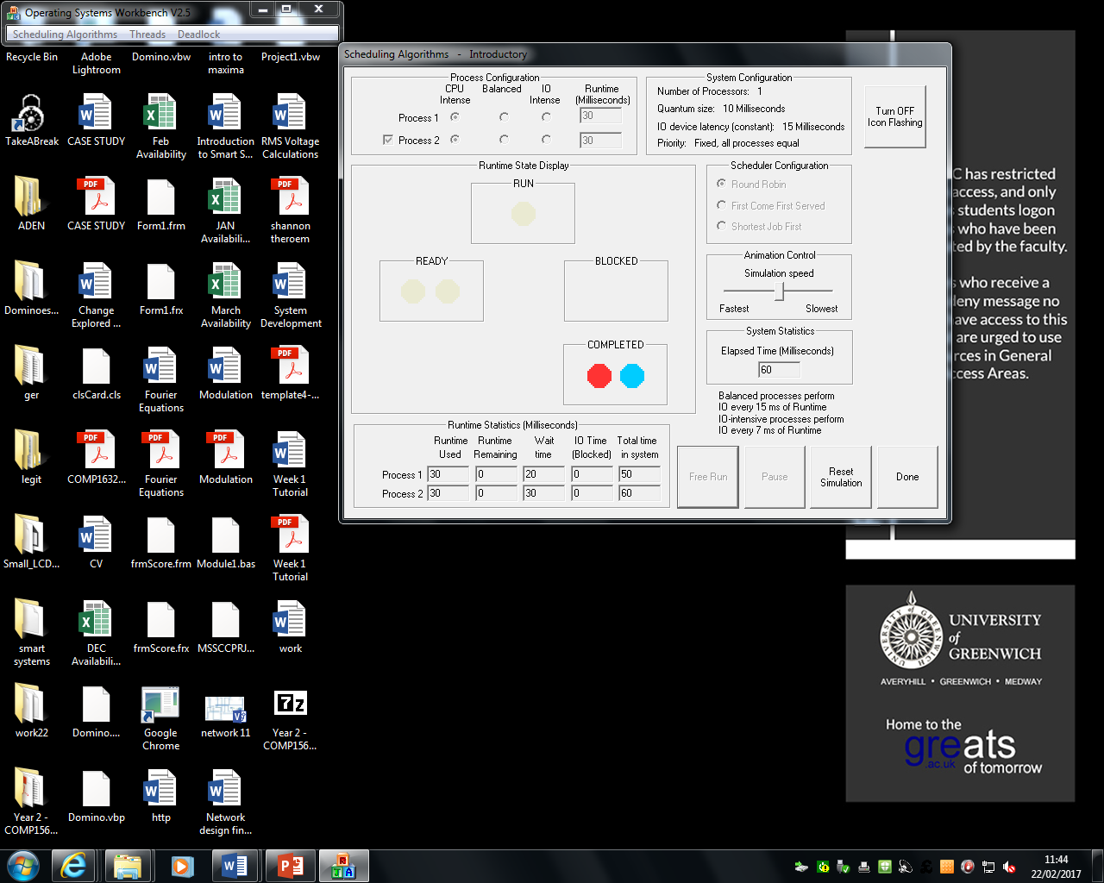

Process 1 300ms

Process 2 30ms

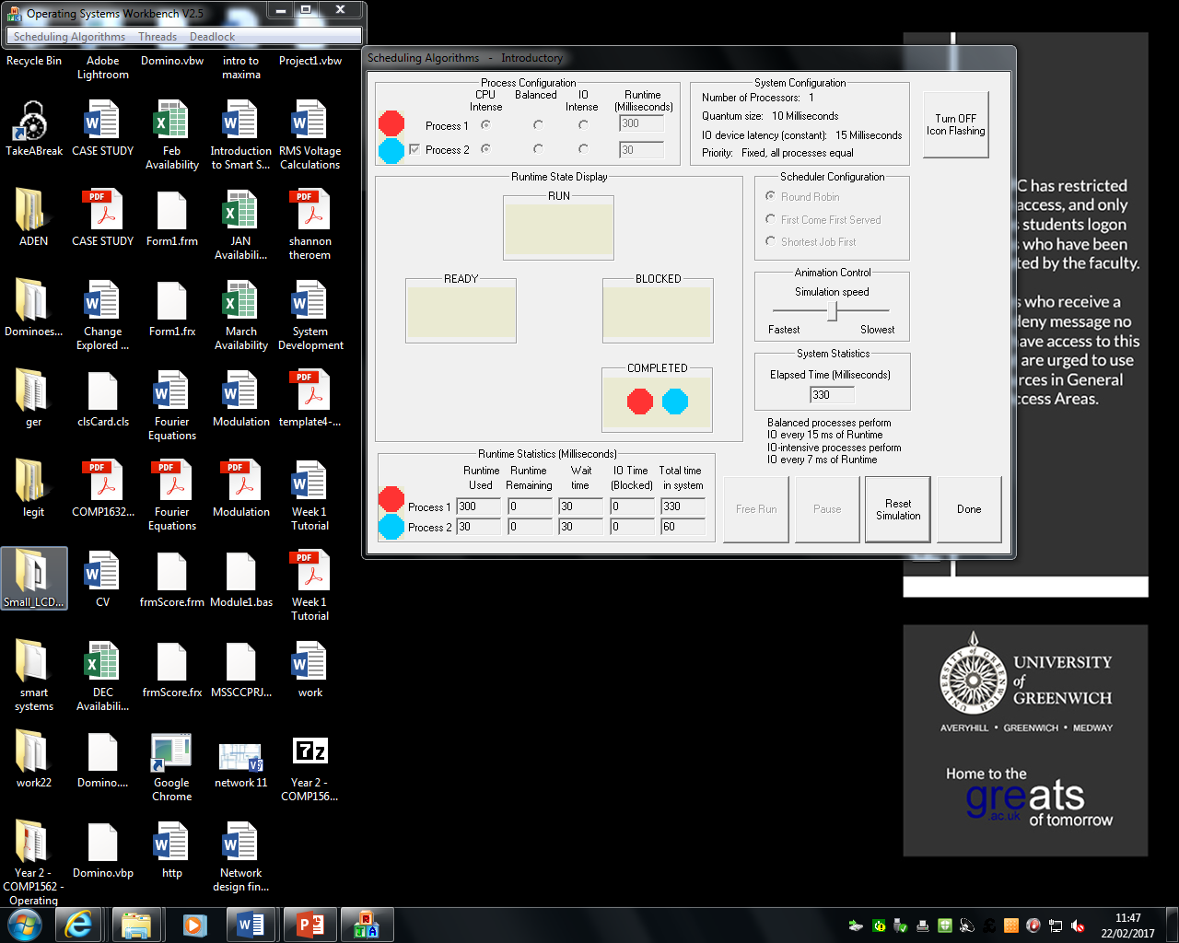

Process 1 30ms

Process 2 300ms

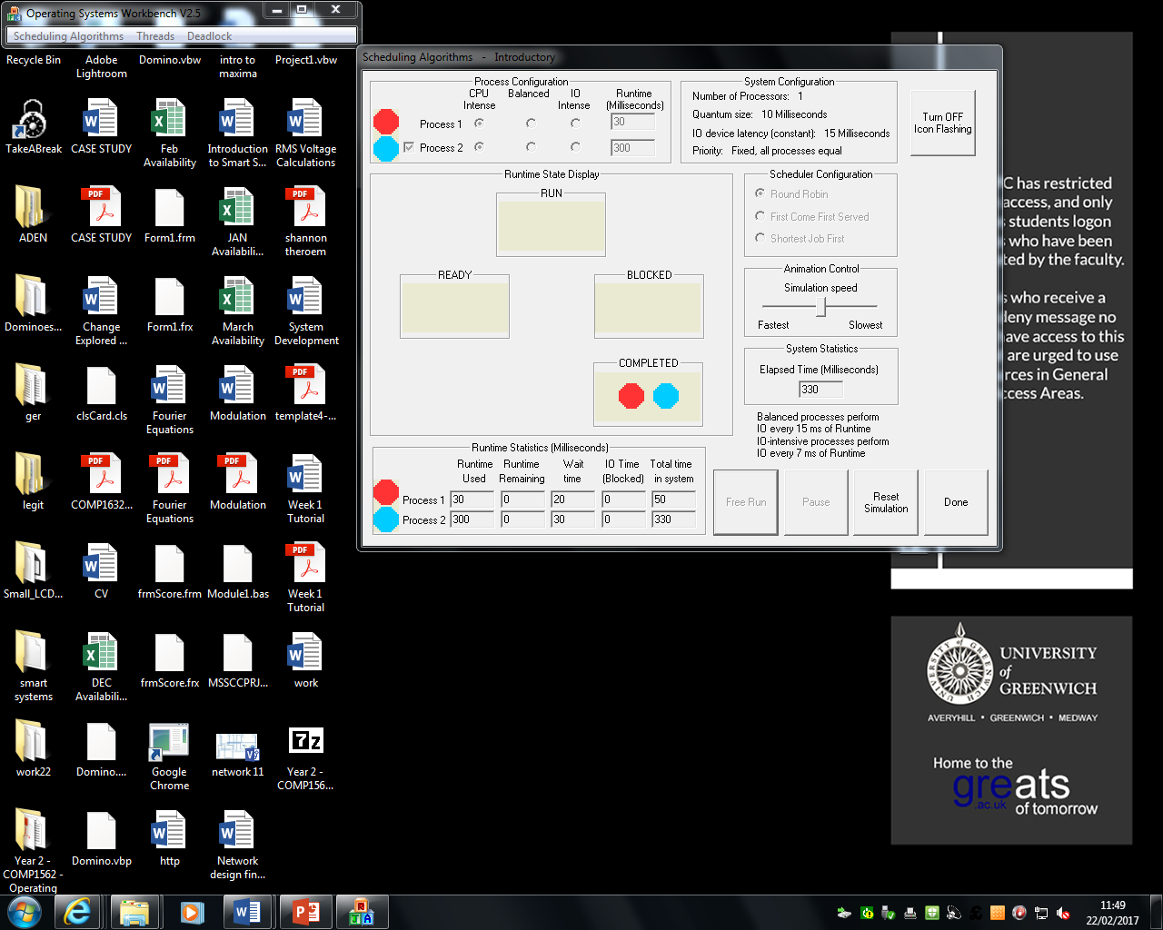

## Shortest Job First

Process 1 30ms

Process 2 30ms

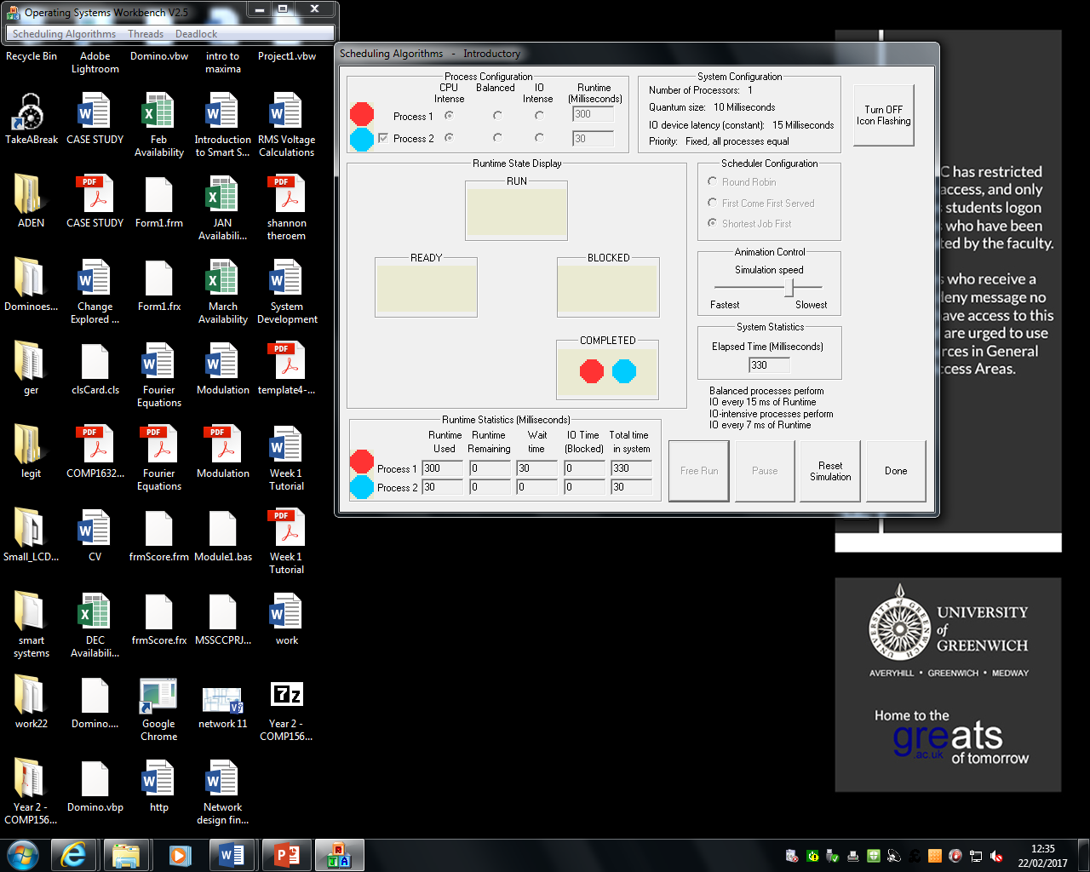

Process 1 300ms

Process 2 30ms

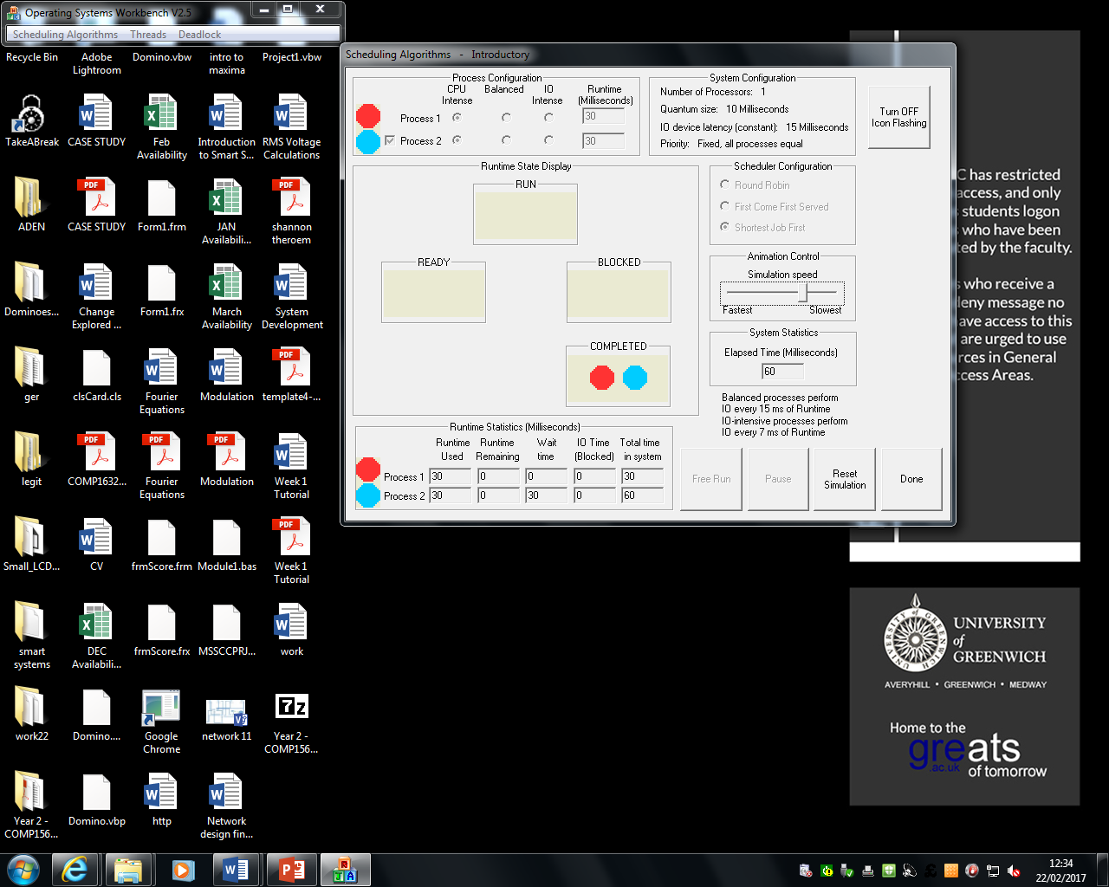

Process 1 30ms

Process 2 300ms

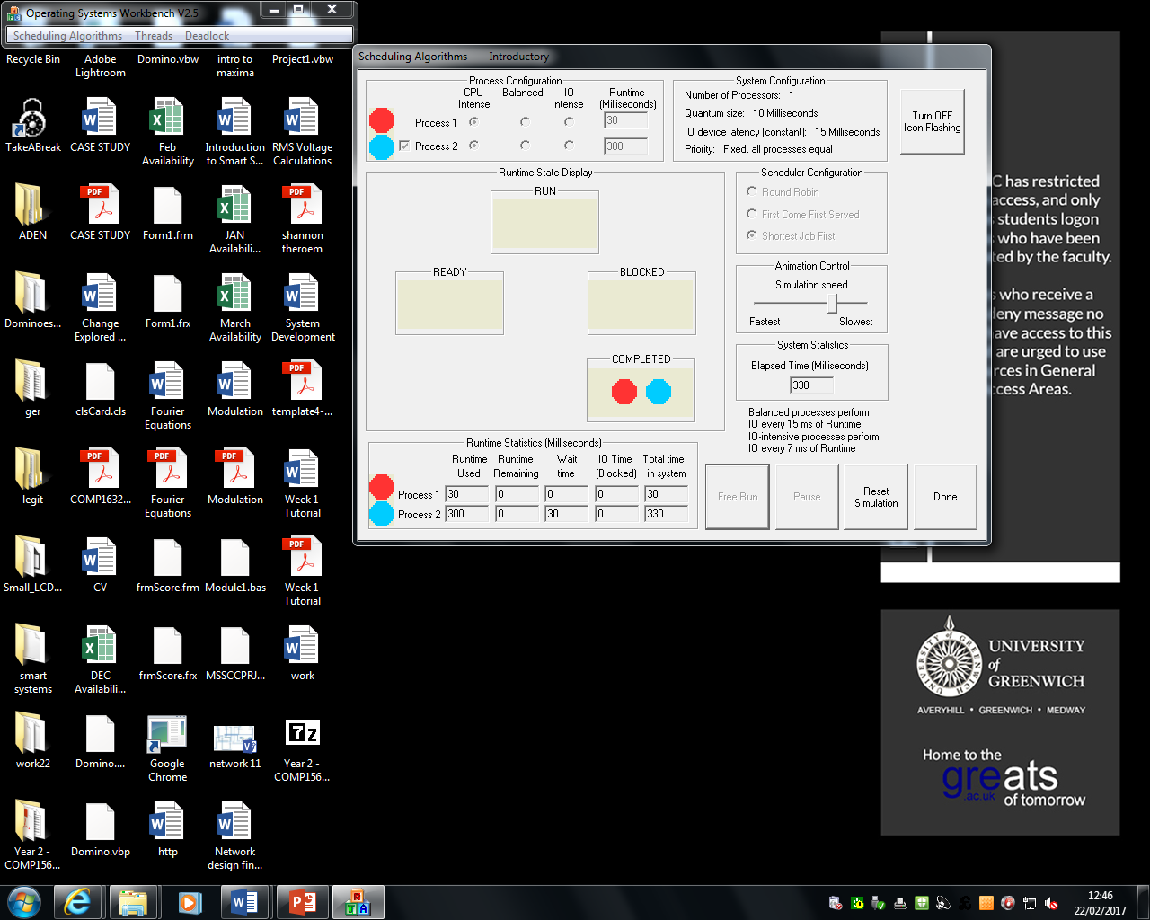

As you can see, the above screenshots are from the Operating System Workbench. Three different algorithms that need to be simulating. They are round robin, first come first served and shortest job first. Each time was monitored for each algorithm. Each algorithms acts differently with different runtimes. For example, as you can see for the screenshots above, shortest job first has a wait time that totals up time for process two. Round robin has a wait time for each process. Different algorithms have different waiting times for each process to be complete. The difference is the waiting time for each of them.

## Task 5.1

## First Comes First Served.

|  |  |  |
| --- | --- | --- |
| Process | Arrival Time [ms] | Service Time [ms] |
| P1 | 0 | 11 |
| P2 | 2 | 8 |
| P3 | 4 | 4 |
| P4 | 6 | 6 |

**Gant Chart**

10

0

200

30

400

*t*[*ms*]

P1

P2

P2

P3

P3

P4

P4

**Average Arrival Time**

= 0+ (11-2) + (19-4) + (23-6)

=41

=41/4

=10.25

**Average Turnaround Time**

=11+17+19+23

Process 1 rrrrrrrrr

Process 2 --wwwwwwwwwrrrrrrrr

Process 3 ----wwwwwwwwwwwwwwwrrrr

Process 4 ------wwwwwwwwwwwwwwwwwwwwwwwrrrrrr

=70

=70/4

=17.5

## Task 5.2

## Shortest Job

Steps

|  |  |
| --- | --- |
| 0-11 | 0 |
| 21-29 | 2 |
| 11-15 | 4 |
| 15-21 | 6 |

**Average waiting time:**

=0+ (21-2) + (11-4) + (15-6)

=0+19+7+9

=35

=35/4

=8.75

**Average Turnaround Time**

Process 1 rrrrrrrrr

Process 2 --wwwwwwwwwwwwwwwwwwwrrrrrrrr

Process 3 ----wwwwwwwrrrr

Process 4 ------wwwwwwwwwrrrrrr

=(11-0)+ (29-2) + (15-4) + (21-6)

=11+27+11+15

=64

=64/4

=16

**Gant Chart**

10

0

20

30

40

*t*[*ms*]

P1

P2

P2

P3

P4

P4

P3

In this task, we had two questions where we had to complete the average waiting time and average turnaround time whilst drawing the Gantt chart for both of the two questions. To calculate the average waiting time for both was to take away the average time on the table from the service time. By doing this for each of the numbers, it was able to get the total number and by dividing this by four since there is four processors. The same process was complete for the turnaround average, but the only difference was used is the turnaround time. Being able to do the first question enabled us to do the second question easily. We did second question very easily than the first one, because it takes harder to understand the first question than the second question.

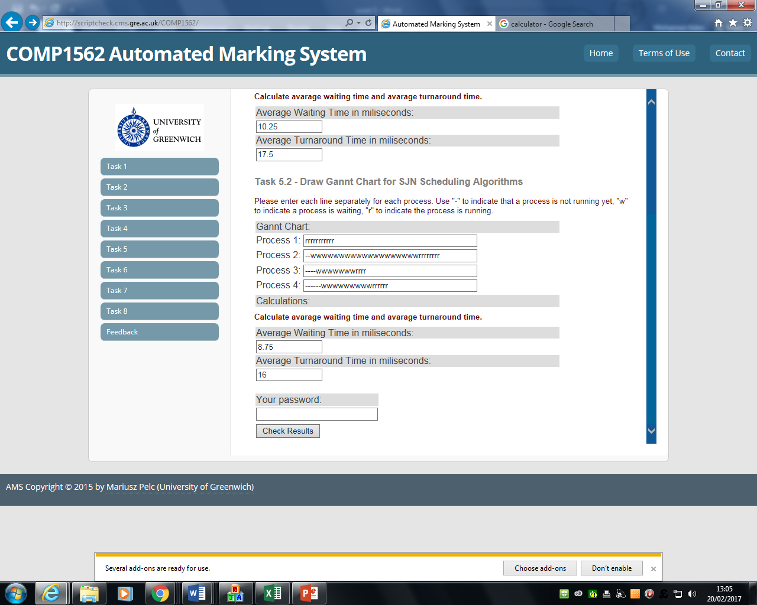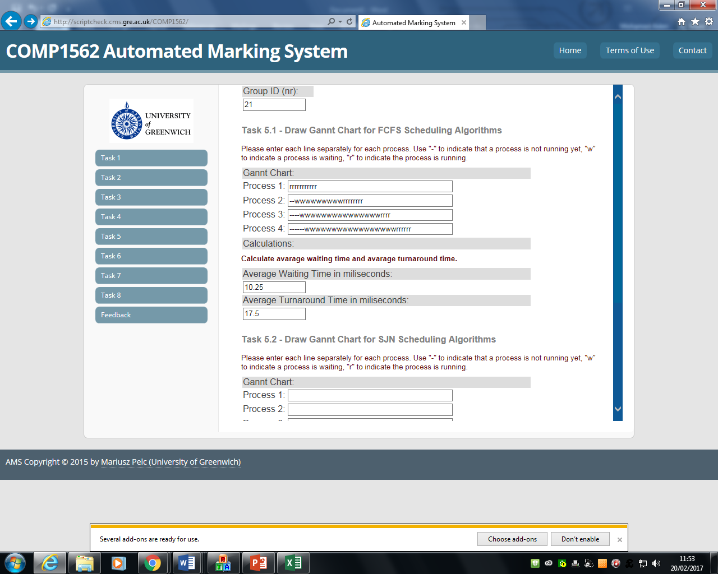

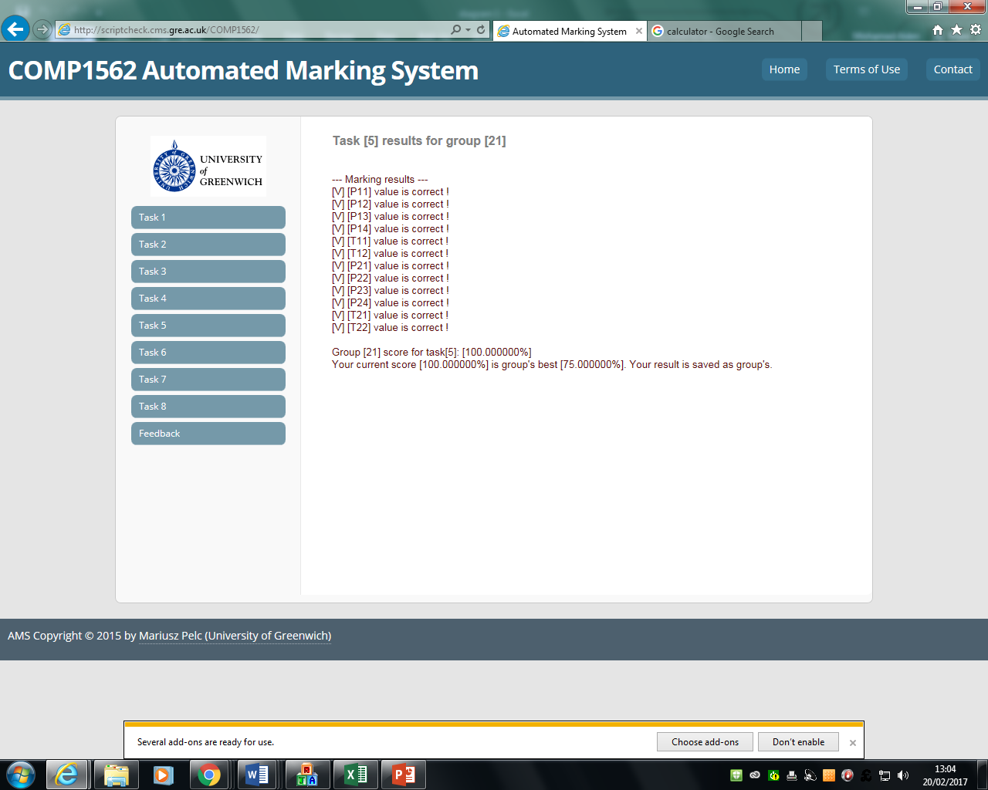

## Reflection

Overall, I felt that this laboratory, it was better than some of the last previous ones that we have completed recently. Even so, we need to take time and effort into any laboratory, because it was the most challenging one out of them all. These challenges took time and effort to be completed and I felt that with my group members, we were able to complete this task and get the result above. Overall, I felt that I have understood the basic understanding and importance of how to run and produce the code effectively.